**Bank_Personal_Loan_Modelling**

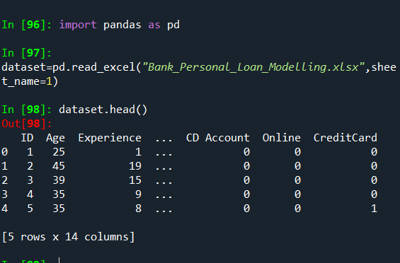

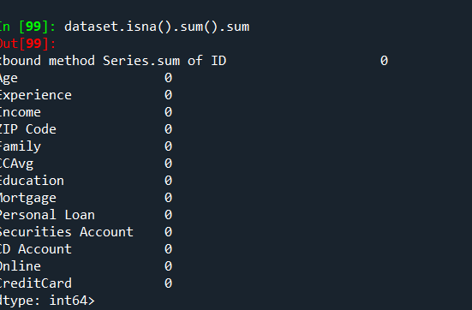



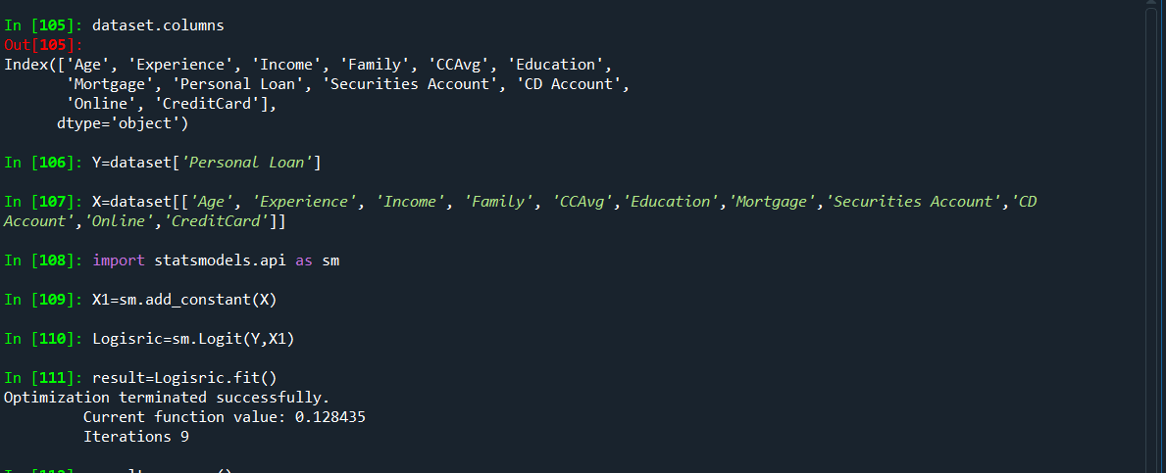

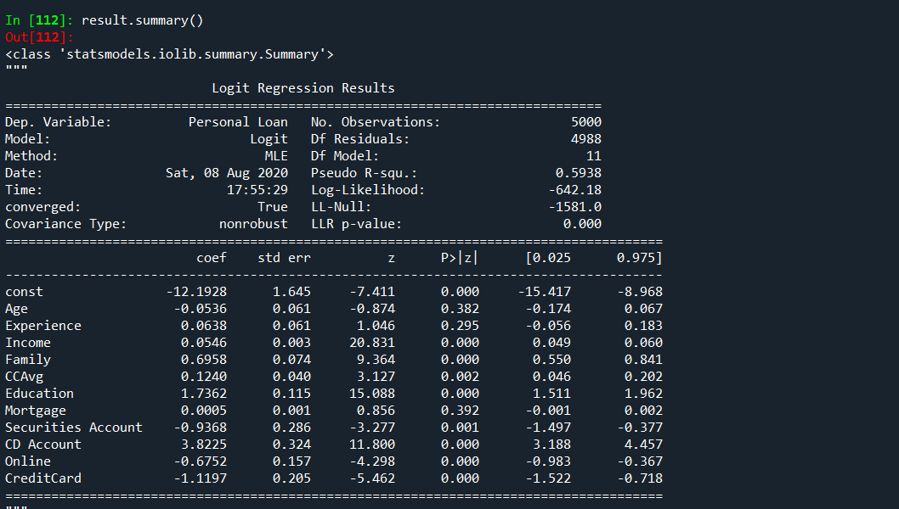

**Inference:**

**1.The more significant Variables get the loan are:**

**Income, Family, CD Account, Online, CreditCard, Education**

**2.The less significant Variables get the loan are:**

**CCAvg , securitiesAccount**

**3.Not significant Variables get the loan are:**

**Age, experience, mortgage**